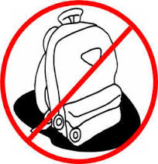

**\*\*\*DAILY QUIZZES SHOULD BE EXPECTED\*\*\***

**Classroom Rules:**

**#1 Follow Directions the First Time**

**#2 Keep Hands, Feet, and Objects to yourself**

**#3 Respect each other and your teacher**

“Do-Overs”

Any assignment may be

resubmitted ONCE in an attempt to improve original grade. (adequate preparation required)

**Every Day** You Must Have:

* **Paper**
* **Pencil or pen**
* **2-pocket folder**
* **7th grade folder (school issued)**

**Grade Weights…**

**Formative 60%**

**(classwork, quizzes, etc.)**

**Summative 40%**

**(tests, projects, etc.)**

World Studies 7

Mrs. Klein

tonyaklein@pickenscountyschools.org

**Join my Remind group!**

**Text @7ad05**

**To 81010**