Name: ________________________________ Date: ________________________ Block: ______
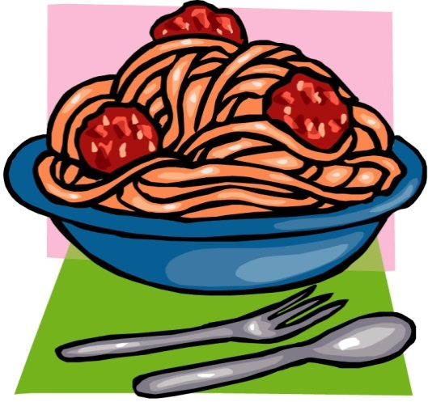

Africa Menu: Spaghetti and meatballs with a side salad

Main Dish (select 1)
- Write a short letter to a friend comparing the various factors that affect education in Kenya and Sudan.

- Write a short letter to a friend describing the government’s role in combating AIDS and famine across Africa.

- Write a short letter to a friend explaining how political, economic, and social conflicts resulted in the independence of South Sudan.

Side Dish – select 2….. (select #1 or #2 and select #3 or #4)
- On a ¼ sheet of white construction paper draw out how you believe HIV/AIDS in Africa has affected the people. On the back of the sheet write a paragraph explain the drawing and how this affects the people who live in Africa.

- On a ¼ sheet of white construction paper draw out how you believe famine in Africa has affected the people. On the back of the sheet write a paragraph explain the drawing and how this affects the people who live in Africa.

- Write a paragraph that compares and contrasts schools in Kenya and Sudan.

- Write a paragraph that compares and contrasts the governments of Kenya and Republic of South Africa.

Dessert (select 1)
- On ½ sheet of construction paper, draw out the economic system of South Africa or Nigeria. The picture must include type of economy, examples of the natural resources, and important industries.

- On ½ sheet of construction paper, draw out something Africa trades with the United States. On the opposite side, write a paragraph explaining why trade is essential and what do the people in Africa use the money earned from exports for.

- On ½ sheet of construction paper show how the natural resources (4 – diamonds, gold, uranium, and oil) are unevenly distributed and what each country does with the money gained from the natural resources.

